What will we be learning?  Unit 12 – Nutrition & diet for sport & exercise | Why this? Why now?  This unit is delivered in Year 12 in the Spring term after unit 1 has been completed. It is delivered during this time as it an interesting unit to start coursework with. | Key Words:  Balanced diet  Macronutrient  Micronutrient  Calories  Basal metabolic rate  Thermic effect  Dehydration  Hypohydration  Hyperhydration  Thermogenics  Aesthetic sports  Disordered eating  Anorexia  Bulimia  Diet trends
What will we learn?
- LO1 – Understand the principles & importance of a balance diet
- LO2 – Understand energy balance
- LO3 – Understand the importance of hydration in sport & exercise
- LO4 – Know the effects of supplements on diet & performance in sport & exercise.
- LO5 – Understand the psychology of healthy eating

What opportunities are there for wider study?
Careers/degree courses
- Sports science
- Physiotherapy
- PE teacher
Further reading:
The Eatwell Guide - GOV.UK (www.gov.uk)
Sports And Hydration: Importance, Guidance And Effects | Healthy Stripe
Supplements in Sports Nutrition (verywellfit.com)
Risks of Eating Disorders in Athletes (verywellfit.com)
How will I be assessed?
- Teacher set assignments on Teams
CAM TECH – SPORT
UNIT 12

LO1 – UNDERSTAND THE PRINCIPLES & IMPORTANCE OF A BALANCED DIET  - Importance of a balance diet  - Components of a balanced diet  - Nutritional advice  - Nutritional requirements | 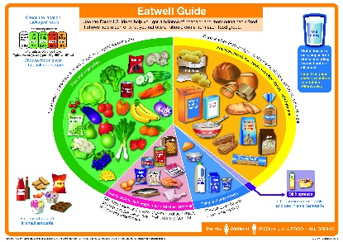
LO2 – UNDERSTAND ENERGY BALANCE  - Energy intake  - Energy balance  - Calorific requirements | 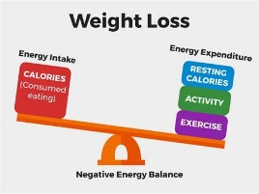
LO3 – UNDERSTAND THE IMPORTANCE OF HYDRATION IN SPORT & EXERCISE  - Hydration – importance, effects of poor hydration, signs and symptoms of poor hydration  - Fluid intake  - Effects on sport & exercise performance | 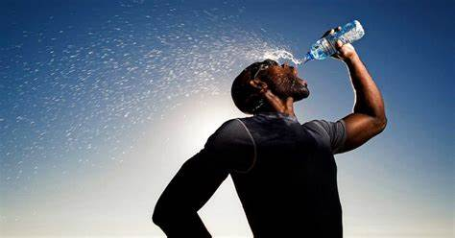
LO4 – KNOW THE EFFECTS OF SUPPLEMENTS ON DIET & PERFORMANCE IN SPORT & EXERCISE  - Supplements  - Methods of taking supplements  - Effects on sport & exercise performance | 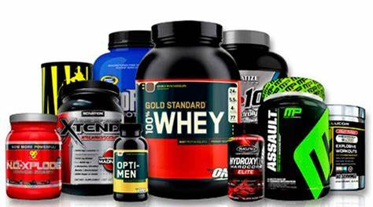
LO5 – UNDERSTAND THE PSYCHOLOGY OF HEALTHY EATING  - Common food issues/factors affecting eating habits  - Causes, signs, symptoms and effects of eating disorders  - Eating disorders in sport  - Aesthetic sports  - Why participation in sport increases chance of eating disorder  - Effects of eating disorders on involvement in sport and exercise. | 